# Use Developer Studio with Leaf Packages

**Scope**: The purpose of this document is show users how to import a Leaf Package into the Developer Studio environment.

**Limitations**: This only works on Linux Machines, Windows is not supported.

**Steps**:

* Setup a leaf workspace somewhere with your desired SDK (e.g. ~/myLeafWorkspace)
* Start DS; it doesn’t have to be in the same workspace than the leaf one
* Configure some preferences
  + In DS, go to the **Package Manager** perspective
  + In **Window > Preferences**, untick the **Developer Studio > Package Manager > Work only with baseline packages** option  
    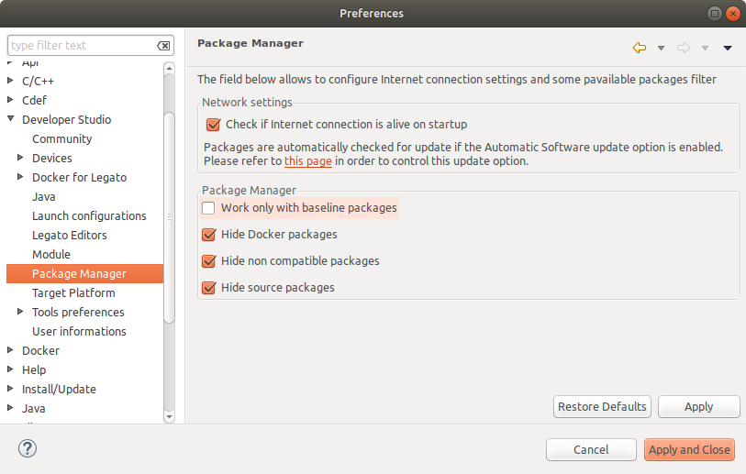
  + In **Available Packages view**, edit the filter to only pick the module you want to work with  
    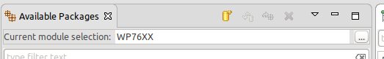
* Install Legato package
  + Click the **Add new Repository** toolbar button  
    
  + Browse to the leaf package folder for Legato (e.g. ~/myLeafWorkspace/leaf-data/current/wp76-legato)  
    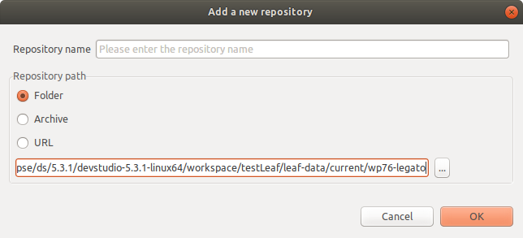
  + DS should detect a Legato package; install it  
    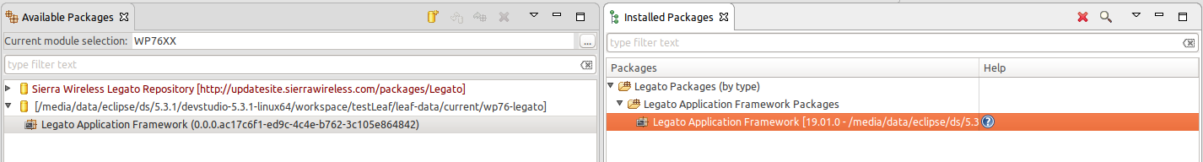
* Install Toolchain package
  + Repeat the three steps above for the toolchain (e.g. ~/myLeafWorkspace/leaf-data/current/wp76-toolchain)  
    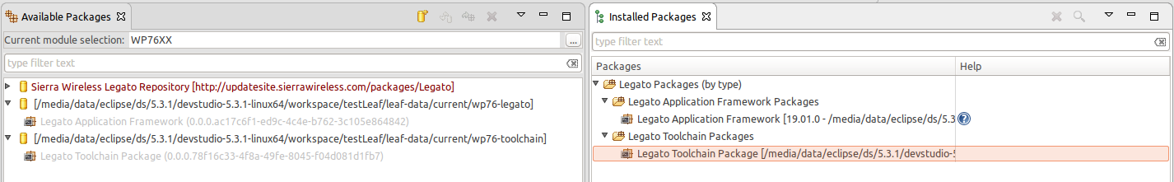
* Setup the “Target Platform”
  + In **Window > Preferences**, go to **Developer Studio > Target Platform**
  + Click **Create** and give a name to your Target Platform
  + Make sure the correct **Module** is selected
  + Tick the just installed toolchain and legato packages in **Package selection**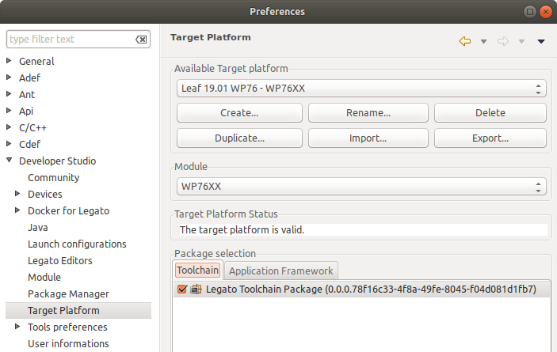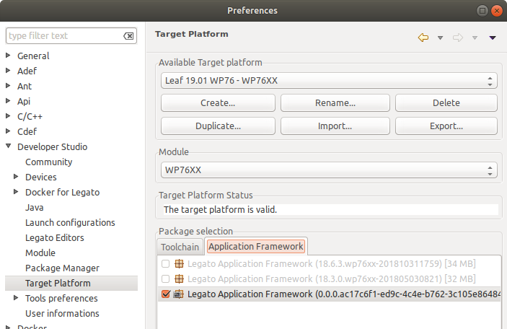
  + Click **Apply and close**
* From there, you can create projects and use DS with the created target platform, as if you were using DS packages…