Example on compiling busybox with the toolchain of WP module

Procedure
- download and install the toolchain in /opt/swi according to your module's FW:
https://source.sierrawireless.com/resources/airprime/software/wp76xx/wp76xx-firmware-latest-release-components/

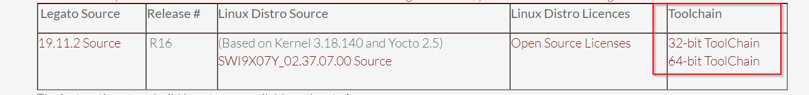

- Go to the following link and download "busybox-1.32.1.tar.bz2" in your linux PC

https://busybox.net/downloads/

- extract it
- type “make menuconfig”
- In the menuconfig,
  - Settings --->Cross Compiler prefix ---> arm-poky-linux-gnueabi-
  - Settings --->Path to sysroot ---> --->/opt/swi/SWI9X07Y_02.37.07.00/sysroots/armv7a-neon-poky-linux-gnueabi

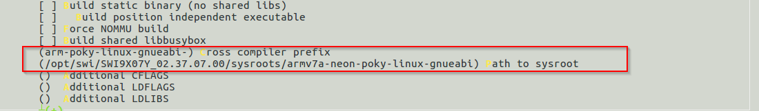

- compile the source code of busybox by the following command:

owner@CNHKG-EX-001367:~/Yocto/sample_c_application/busybox_cross_compile/busybox-1.32.1$ make CROSS_COMPILE=/opt/swi/SWI9X07Y_02.37.07.00/sysroots/x86_64-pokysdk-linux/usr/bin/arm-poky-linux-gnueabi/arm-poky-linux-gnueabi-

- A new binary "./busybox " will be generated.

- Pass this busybox binary to your WP module /tmp folder by SCP and type:

root@swi-mdm9x28-wp:~# chmod 777 /tmp/busybox
root@swi-mdm9x28-wp:~# /tmp/busybox
BusyBox v1.32.1 (2023-04-06 13:46:39 HKT) multi-call binary.
BusyBox is copyrighted by many authors between 1998-2015.
Licensed under GPLv2. See source distribution for detailed
copyright notices.

Usage: busybox [function [arguments]...]
or: busybox --list[-full]
or: busybox --show SCRIPT
or: busybox --install [-s] [DIR]
or: function [arguments]...

BusyBox is a multi-call binary that combines many common Unix
utilities into a single executable. Most people will create a
link to busybox for each function they wish to use and BusyBox
will act like whatever it was invoked as.

Currently defined functions:
[, [[, acpid, add-shell, addgroup, adduser, adjtimex, arch, arp,
arping, ash, awk, base64, basename, bc, beep, blkdiscard, blkid,
blockdev, bootchartd, brctl, bunzip2, bzcat, bzip2, cal, cat, chat,
chattr, chgrp, chmod, chown, chpasswd, chpst, chroot, chrt, chvt,
cksum, clear, cmp, comm, conspy, cp, cpio, crond, crontab, cryptpw,
cttyhack, cut, date, dc, dd, deallocvt, delgroup, deluser, depmod,
devmem, df, dhcprelay, diff, dirname, dmesg, dnsd, dnsdomainname,
dos2unix, dpkg, dpkg-deb, du, dumpkmap, dumpleases, echo, ed, egrep,
eject, env, envdir, envuidgid, ether-wake, expand, expr, factor,
fakeidentd, fallocate, false, fatattr, fbset, fbsplash, fdflush,
fdformat, fdisk, fgconsole, fgrep, find, findfs, flock, fold, free,
freeramdisk, fsck, fsck.minix, fsfreeze, fstrim, fsync, ftpd, ftpget,
ftpput, fuser, getopt, getty, grep, groups, gunzip, gzip, halt, hd,
hdparm, head, hexdump, hexedit, hostid, hostname, httpd, hush, hwclock,
i2cdetect, i2cdump, i2cget, i2cset, i2ctransfer, id, ifconfig, ifdown,
ifenslave, ifplugd, ifup, inetd, init, insmod, install, ionice, iostat,
ip, ipaddr, ipcalc, ipcrm, ipcs, iplink, ipneigh, iproute, iprule,
iptunnel, kbd_mode, kill, killall, killall5, klogd, last, less, link,
linux32, linux64, linuxrc, ln, loadfont, loadkmap, logger, login,
logname, logread, losetup, lpd, lpq, lpr, ls, lsattr, lsmod, lsof,
lspci, lsscsi, lsusb, lzcat, lzma, lzop, makedevs, makemime, man,
md5sum, mdev, mesg, microcom, mim, mkdir, mkdosfs, mke2fs, mkfifo,
mkfs.ext2, mkfs.minix, mkfs.vfat, mknod, mkpasswd, mkswap, mktemp,
modinfo, modprobe, more, mount, mountpoint, mpstat, mt, mv, nameif,
nanddump, nandwrite, nbd-client, nc, netstat, nice, nl, nmeter, nohup,
nologin, nproc, nsenter, nslookup, ntpd, nuke, od, openvt, partprobe,
passwd, paste, patch, pgrep, pidof, ping, ping6, pipe_progress,
pivot_root, pkill, pmap, popmaildir, poweroff, powertop, printenv,
printf, ps, pscan, pstree, pwd, pwdx, raidautorun, rdate, rdev,
readahead, readlink, readprofile, realpath, reboot, reformime,
remove-shell, renice, reset, resize, resume, rev, rm, rmdir, rmmod,
route, rpm, rpm2cpio, rtcwake, run-init, run-parts, runlevel, runsv,
runsvdir, rx, script, scriptreplay, sed, sendmail, seq, setarch,
setconsole, setfattr, setfont, setkeycodes, setlogcons, setpriv,
setserial, setsid, setuidgid, sh, sha1sum, sha256sum, sha3sum,
sha512sum, showkey, shred, shuf, slattach, sleep, smemcap, softlimit,
sort, split, ssl_client, start-stop-daemon, stat, strings, stty, su,
sulogin, sum, sv, svc, svlogd, svok, swapoff, swapon, switch_root,
sync, sysctl, syslogd, tac, tail, tar, taskset, tc, tcpsvd, tee,
telnet, telnetd, test, tftp, tftpd, time, timeout, top, touch, tr,
traceroute, traceroute6, true, truncate, ts, tty, ttysize, tunctl,
ubiattach, ubidetach, ubimkvol, ubirename, ubirmvol, ubirsvol,
ubiupdatevol, udhcpc, udhcpc6, udhcpd, udpsvd, uevent, umount, uname,
unexpand, uniq, unix2dos, unlink, unlzma, unshare, unxz, unzip, uptime,
users, usleep, uudecode, uuencode, vconfig, vi, vlock, volname, w,
wall, watch, watchdog, wc, wget, which, who, whoami, whois, xargs, xxd,
xz, xzcat, yes, zcat, zcip

