Sending AT command in Legato application

Using system() API
- Import the following application inside Developer Studio

- Please note that we need to disable the sandbox option in ATcmd_Test.adef in order to access AT command port in Legato application 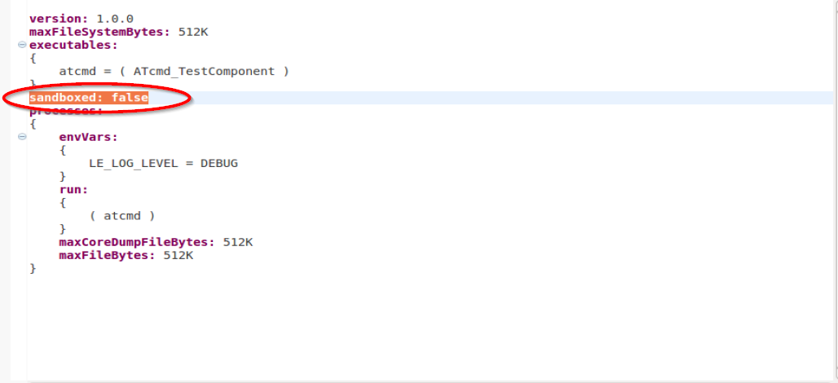
- In ATcmd_Test.c, configure the WP8 phone number in
#define Phone_Number "97576275"

- In WP8 console, enter “cm sms monitor &” to monitor the received SMS
- Once the application is run, it will send SMS to itself.
- You should see the following in the WP8 console:
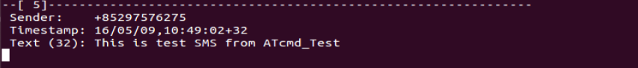

Using open() API
- Import the following application inside Developer Studio

- Please note that we need to disable the sandbox option in ATcmd_Test2.adef in order to access AT command port in Legato application
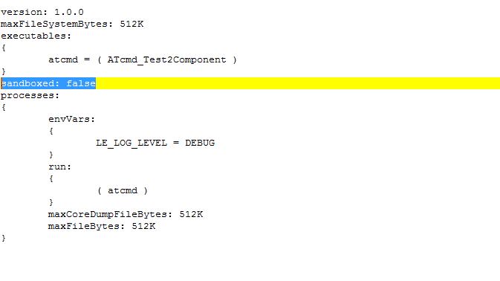

- In ATcmd_Test2.c, configure the WP8 phone number in
#define Phone_Number "97576275"

- In WP8 console, enter “cm sms monitor &” to monitor the received SMS
- Once the application is run, it will send SMS to itself.
- You should see the following in the WP8 console:
