How to use GPIO as wakeup source on WP77xx MangOH Red board

Prerequisite
- Please note that the test below is done based on R9.1 FW on WP77xx.

root@swi-mdm9x28-wp:~# cm info
Device: WP7702
IMEI: 352653090002791
IMEISV: 2
FSN: VU735370340201
Firmware Version: SWI9X06Y_02.16.06.00 7605a6 jenkins 2018/06/20 17:56:12
Bootloader Version: SWI9X06Y_02.16.06.00 7605a6 jenkins 2018/06/20 17:56:12
MCU Version: 002.009
PRI Part Number (PN): 9907365
PRI Revision: 001.001
Carrier PRI Name: GENERIC
Carrier PRI Revision: 001.028_001
SKU: 1103530
Last Reset Cause: Power Down
Resets Count: Expected: 202 Unexpected: 28

- Please make sure there is no application or task is blocking the sleep mode of module. You can check by “cat /sys/power/wake_lock” and ensure there is nothing returned.
- This document will use GPIO36 as wake up source. If you want to use other GPIO pin, please make sure it can wake up the module by checking this inside PTS.

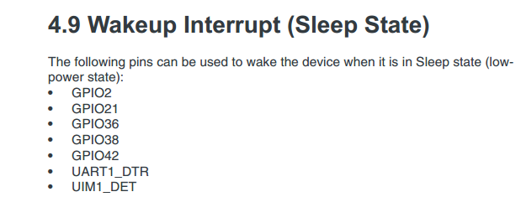

Test Procedure
- import the following "gpioCf3SSDemo.rar" to Developer Studio

- compile the application and download to the module
- after boot up, type "app start gpioCf3SSDemo"
- remove the USB cable and wait until the module goes to sleep mode. During sleep mode, there should be no response on UART console.
- toggle GPIO36 (CN312 pin3 on MangOH Red board) rising edge or falling edge can make the module wake up for awhile about 10 seconds.
- When module wakes up, the UART console can respond. Also, from the following we can know the application is blocking the module to sleep during the 10 seconds.

root@swi-mdm9x28-wp:~# cat /sys/power/wake_lock
legato_GPIO42_wakeup_gpioCf3SSDemo

