Thank you

Case is a little more complex. They will use Java agent JNI to call Legato API libraries in “C”

We have

* One process A (Agent A) implementing a propietary AT commands and business logic.
* Sencond process B (Agent B) in charge of monitoring process and update of Agent A

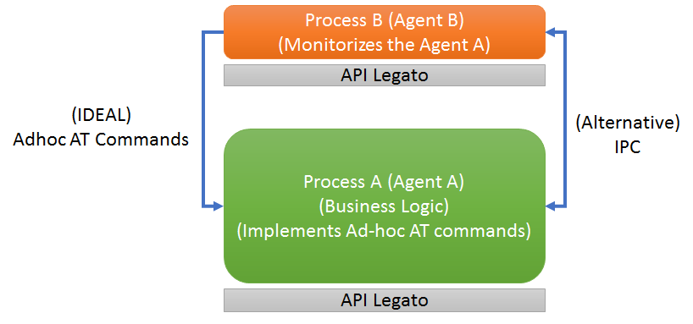

* Can we do calls to AT ad-hoc commands from process B so it´s process A the one sending the commands and receiving the answers as if it was a serial port behaviour?
* If it´s not possible, can we use IPC to communicate both process? Is there any sample for Java?

Thank you