Example on Secure boot implementation for WP76xx

- The test below has been tested on R13.3 yocto source code.
- Download the toolchain according to your software release.
E.g. R13.3 components
https://source.sierrawireless.com/resources/airprime/software/wp76xx/wp76xx-firmware-release-13,-d-,1-components/#sthash.13BE7Elj.dpbs

- Install the toolchain to /opt/swi on your linux PC
sh poky-swi-ext-glibc-x86_64-meta-toolchain-swi-armv7a-neon-toolchain-swi-SWI9X07Y_02.28.03.05.sh

- copy the android_signature_add.sh to your signing directory ,e.g. /home/owner/Yocto/tools/signing_dir
- Environment setup
export ANDROID_SIGNING_DIR=/home/owner/Yocto/tools/signing_dir
cd /home/owner/Yocto/tools/signing_dir

- copy hdrcnv from toolchain to signing directory
cp /opt/swi/SWI9X07Y_02.28.03.05/sysroots/x86_64-pokysdk-linux/usr/bin/hdrcnv /home/owner/Yocto/tools/signing_dir

- Copy the following two files from the build system to the signing directory after successfully compile the Linux yocto source code
cp -rf /home/owner/Yocto/WP76/R13.3/yocto/build_bin/tmp/sysroots-components/x86_64/android-signing-native/usr/share/android-signing/* /home/owner/Yocto/tools/signing_dir

cp -rf /home/owner/Yocto/WP76/R13.3/yocto/meta-swi/meta-swi-mdm9xxx/recipes-bsp/android-signing/files/swi-make-cert-chain.sh /home/owner/Yocto/tools/signing_dir

- Set up the certificate
chmod 777 make_key
./make_key mykey '/C=US/ST=California/L=Mountain View/O=Android/OU=Android/ CN=Android/emailAddress=android@android.com'

(When prompted, choose a password to protect the private key file that is being generated. The private/public key pair (mykey.pk8, mykey.x509.pem) are created in the current signing folder.)

- Replace the default (dummy) key pair with your new key pair

cp mykey.pk8 security/verity.pk8
cp mykey.x509.pem security/verity.x509.pem

- Open swi-key-cwe.sh, in line 14, change the path of HDRCNV according to build environment
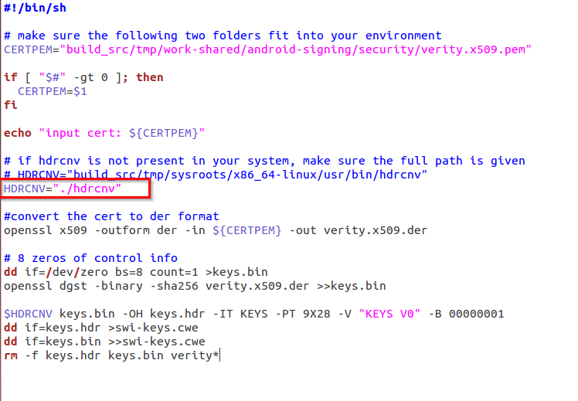

- Generate the keystore CWE image (swi-keys.cwe) corresponding to your new key
chmod 777 swi-key-cwe.sh
chmod 777 hdrcnv
$ANDROID_SIGNING_DIR/swi-key-cwe.sh security/verity.x509.pem

- Copy the unsigned images (i.e. aboot, kernel, rootfs) to signing directory

cp /home/owner/Yocto/WP76/R13.3/yocto/build_bin/tmp/deploy/images/swi-mdm9x28-wp/appsboot.mbn.unsigned /home/owner/Yocto/tools/signing_dir
cp /home/owner/Yocto/WP76/R13.3/yocto/build_bin/tmp/deploy/images/swi-mdm9x28-wp/boot-yocto-mdm9x28.4k.unsigned.img /home/owner/Yocto/tools/signing_dir
cp /home/owner/Yocto/WP76/R13.3/yocto/build_bin/tmp/deploy/images/swi-mdm9x28-wp/mdm9x28-image-minimal-swi-mdm9x28-wp.ubi /home/owner/Yocto/tools/signing_dir

- Sign the aboot and kernel
chmod 777 ./android_signature_add.sh
./android_signature_add.sh /boot boot-yocto-mdm9x28.4k.unsigned.img boot-yocto-mdm9x28.4k.img
(need to your password set in step 8 above)
./android_signature_add.sh /aboot appsboot.mbn.unsigned appsboot.mbn
(need to your password set in step 8 above)
- Install swicwe tool
https://source.sierrawireless.com/resources/airprime/software/swicwe/#sthash.sno65XlI.dpbs

- Combine the signed files as yocto.cwe (swicwe version at least to be v1.2)
swicwe --YCWE --pid 9X28 --lk appsboot.mbn --kernel boot-yocto-mdm9x28.4k.img --rootfs mdm9x28-image-minimal-swi-mdm9x28-wp.ubi -v SWI9X07Y_02.28.03.05 -o yocto.cwe

- Copy the whole signing directory from linux PC to Windows 10 platform.
- Open command prompt in Window as administrator
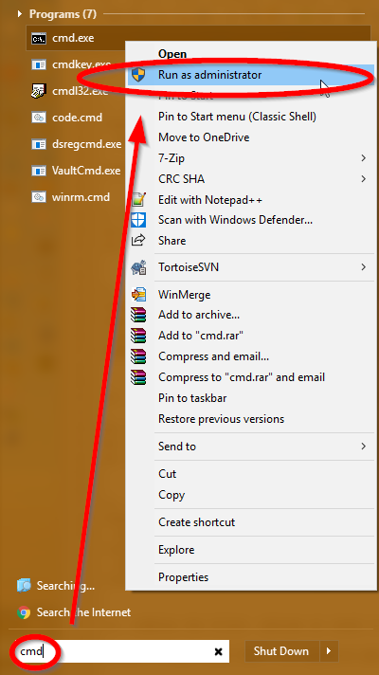

- Load the final image yocto.cwe to module by FDT
fdt2.exe -f C:\Users\jyi\Desktop\signing_dir\yocto.cwe

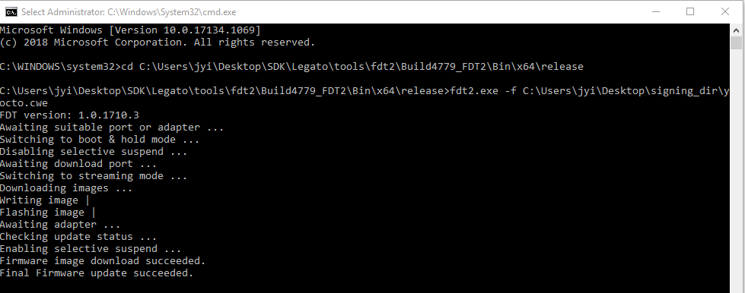

- Enable Customer Secure Boot in AT command port
AT!ENTERCND="A710"
AT!OEMAUTH=1

- Download the keystore CWE image to module by FDT (Please note that the command prompt has to be "run as administrator")
fdt2.exe -f C:\Users\jyi\Desktop\signing_dir\swi-keys.cwe

- Now secure boot is enabled and module should be able to boot in to console.
- For a new built yocto image next time, start with step 12 above to sign the image.
DO NOT regenerate the key and swi-keys.cwe !!!!!
- In case downloading a not-signed image on this secure boot enabled module, we will see the following in UART console:

B - 25372980 - cert signature failure, b
B - 25373346 - BOOT_HOLD=3,DOWNLOADER=boot,VERSION=Thu Oct 31 04:32:40 UTC 2019,TYPE=APPL,SUBIMAGE=APPS,ERROR=Flash write failed: Secboot invalid cert chain (0X92),STATUS=FAIL

If you see this, after reboot, the device cannot run properly, you need to download the signed image again in step 18 above by fdt tool.

