Example on compiling Azure-IoT-SDK-for-Embedded-C with the toolchain of WP76 module

Background
- The Azure SDK for Embedded C is designed to allow small embedded (IoT) devices to communicate with Azure services.
- The cross-compilation example below is done with Ubuntu 16 with CMAKE version 3.5.1
- The version of Azure-IoT-SDK-for-Embedded-C in this document is 1.11.0.

Procedure
- Download and install the toolchain in /opt/swi according to your module's FW. For example, below is the toolchain of firmware R16:
https://source.sierrawireless.com/resources/airprime/software/wp76xx/wp76xx-firmware-latest-release-components/

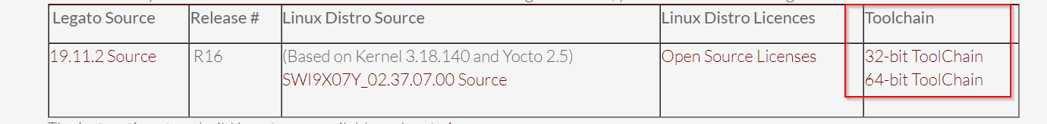

- Download the main branch of Azure-IoT-SDK-for-Embedded-C source code to “Source” folder.
mkdir Source
cd Source
git clone --recursive https://github.com/Azure/azure-iot-sdk-c.git

- Put the following toolchain-rpi.cmake to ./azure-iot-sdk-c/build_all/linux

- Starting from Azure-IoT-SDK-for-Embedded-C tag version 1.9.0, in ./azure-iot-sdk-c/CMakeLists.txt, around line 237, we need to add the following before "# Turn off tests for dependencies #":

# if any compiler has a command line switch called "OFF" then it will need special care
if (NOT "${compileOption_C}" STREQUAL "")
set(CMAKE_C_FLAGS "${compileOption_C} ${CMAKE_C_FLAGS}")
endif()

if (NOT "${compileOption_CXX}" STREQUAL "")
set(CMAKE_CXX_FLAGS "${compileOption_CXX} ${CMAKE_CXX_FLAGS}")
endif()

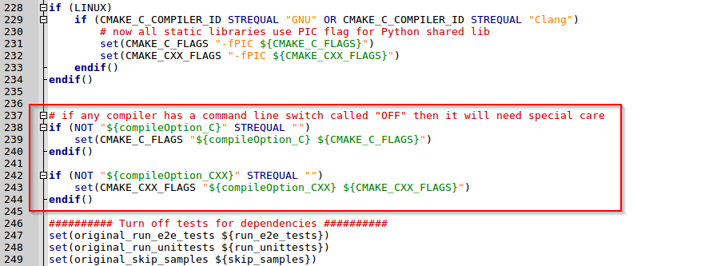

- If your CMAKE version is smaller than 3.7, there is no "GREATER_EQUAL" arguments implementation in CMakeLists.txt, we need to manually change "GREATER_EQUAL" to "GREATER OR EQUAL" argument in "c-utility/CMakeLists.txt", around line 132:

if (DEFINED OPENSSL_VERSION AND ((${OPENSSL_VERSION} GREATER 3) OR (${OPENSSL_VERSION} EQUAL 3)))
add_definitions(-DOPENSSL_API_COMPAT=0x10101000L)
endif()
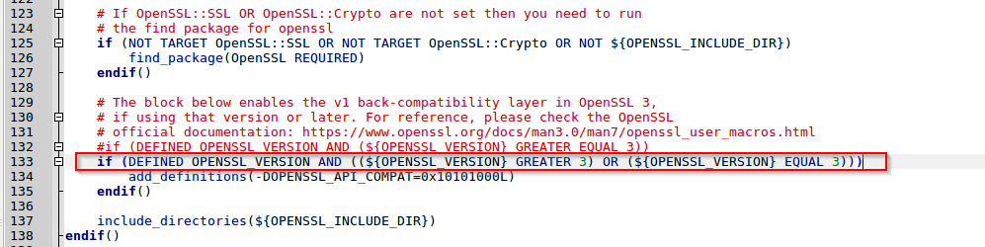

- Type the following to cross compile the SDK with toolchain of WP76 module according to your build environment:

export RPI_ROOT=/opt/swi/SWI9X07Y_02.37.07.00/sysroots/armv7a-neon-poky-linux-gnueabi
cd ./azure-iot-sdk-c/build_all/linux
./build.sh --toolchain-file toolchain-rpi.cmake -cl --sysroot=$RPI_ROOT

- If compile successfully, you should see the terminal like this:

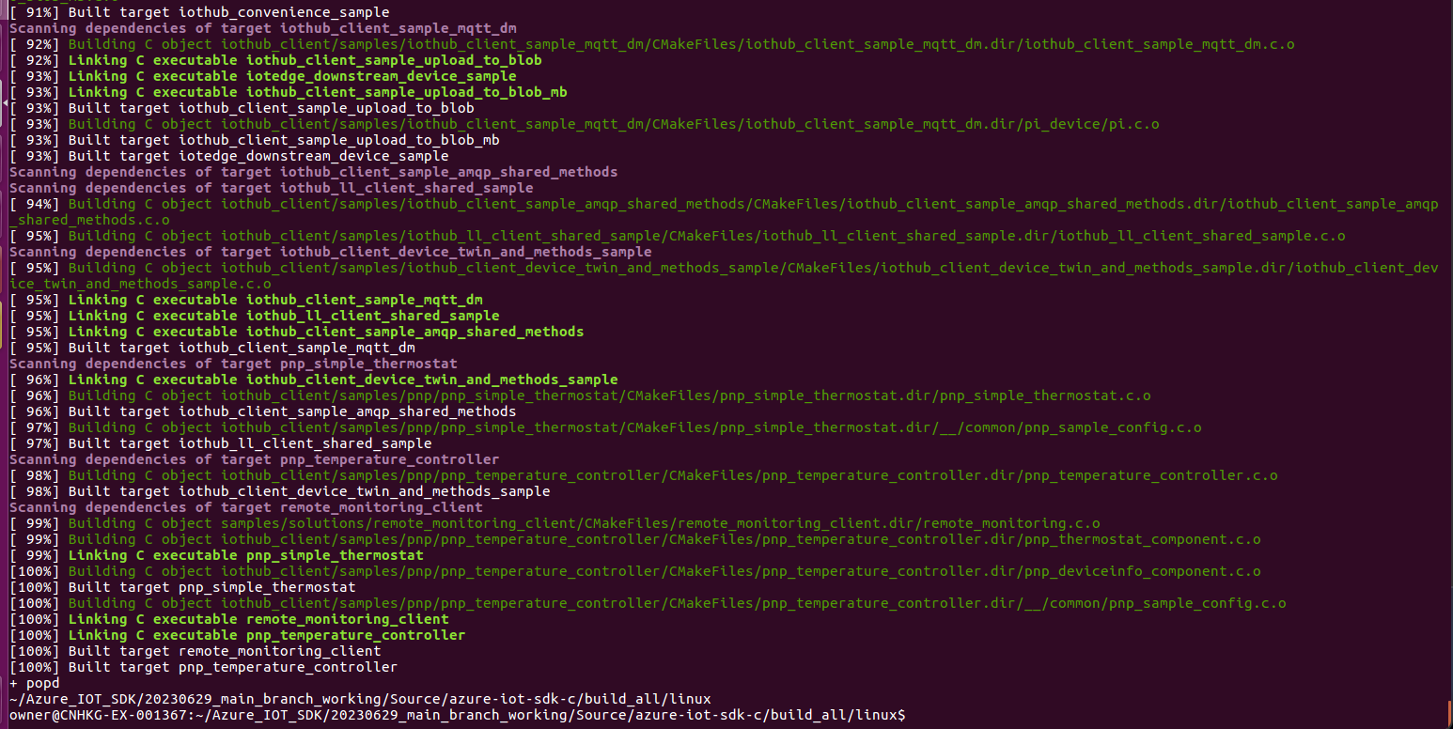

- Transfer the sample binary (e.g. ./azure-iot-sdk-c/cmake/ samples/solutions/remote_monitoring_client/remote_monitoring_client) to /tmp folder of module by SCP tool

- Type the following in WP76 module to run the sample binary:

root@swi-mdm9x28-wp:/tmp# chmod 777 remote_monitoring_client
root@swi-mdm9x28-wp:/tmp# ./remote_monitoring_client

This sample simulates a Chiller device connected to the Remote Monitoring solution accelerator

Creating IoTHub handle
Error: Time:Sun Jan 6 08:23:17 1980 File:/home/owner/Azure_IOT_SDK/20230629_main_branch_working/Source/azure-iot-sdk-c/iothub_client/src/iothub_client_core_ll.c Func:IoTHubClientCore_LL_CreateFromConnectionString Line:1417 Tokenizer error
Error: Time:Sun Jan 6 08:23:17 1980 File:/home/owner/Azure_IOT_SDK/20230629_main_branch_working/Source/azure-iot-sdk-c/iothub_client/src/iothub_client_core_ll.c Func:IoTHubClientCore_LL_CreateFromConnectionString Line:1555 iotHubName is not found
Error: Time:Sun Jan 6 08:23:17 1980 File:/home/owner/Azure_IOT_SDK/20230629_main_branch_working/Source/azure-iot-sdk-c/iothub_client/src/iothub_client_core.c Func:create_iothub_instance Line:1115 Failure creating iothub handle
Failure creating IotHub device. Hint: Check your connection string.

